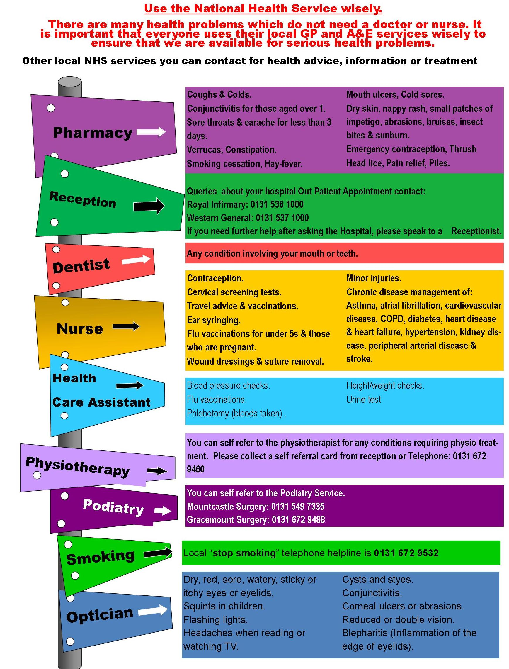

Visit your local Pharmacy or telephone your local smoking cessation hotline on 08452 17 77 07

**Podiatry new patient appointments can be made by contacting the Referral Management Centre based at Cambuslang Gate Cambuslang on 0141 584 2502.**

**You can self refer to the Physiotherapist for any condition requiring physio treatment. Please collect a self referral card from Reception at the Surgery.**

**Queries about your hospital outpatient appointment, contact:**

**Queen Elizabeth 0141 201 1100**

**Victoria Infirmary 0141 201 6000**

**Hairmyres 01355 220292**

**To make an appointment with the GP/Nurse or Health Care Assistant contact Practice reception**

**Contraception – injection/tablet Chronic Disease Management of**

**/implants/advice Asthma, Atrial Fibrillatio, Cardio**

**Cervical Screening tests vascular disease, COPD,**

**Travel advice and vaccinations Diabetes, Heart Disease and**

**Ear Review Heart Failure, Hypertension,**

**Flu vaccinations Kidney Disease, Peripheral**

**Minor injuries Arterial Disease and Stroke**

**Blood pressure checks Height/weight checks**

**Flu vaccinations New Patient checks**

**Phlebotomy (blood taken) Urinalysis**